#1_Program that calculates the average of the marks and the percentage of a student in six subjects (each out of Hundred)>>>

#include <stdio.h>

int main()

{  float m,e,s,h,u,c,sum,avg,per;

   printf("Please enter all your marks out of hundred. "

"Now enter your marks in Mathametics  here: ");

   scanf("%f",&m);

   printf("Enter your marks in English here: ");

   scanf("%f",&e);

   printf("Enter your marks in Science here: ");

   scanf("%f",&s);

   printf("Enter your marks in Hindi here: ");

   scanf("%f",&h);

   printf("Enter your marks in Urdu here: ");

   scanf("%f",&u);

   printf("Enter your marks in Computer Science here: ");

   scanf("%f",&c);

   sum=m+e+s+h+u+c;

   avg=sum/6;

   per=(sum/600)*100;

/*if the marks are entered out of hundred average (avg) will be equal to the percentage but in other situations per variable will be required*/

   printf("Your average marks are %f and your percentage is %f .",avg,per);

   return 0;

}

Execution;

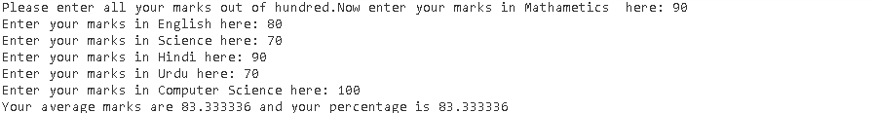

#2_Program that find the gross salary of an employee >>>

/*Given Data is:

Basic pay =22,600

D.A. = 40% of basic pay

C.A. = 78% of basic pay

To find: Gross Salary*/

#include <stdio.h>

int main(){

    //variable b for basic pay

    float b=22600;

//variable d for D.A.

float d=(b*40)/100;

//Note that b* (40/100) will not give the right result.

    //variable c for C.A.

    float c=(b*78)/100;

    //variable g for gross salary

    float g=b+d+c;

    printf("The Gross income of the employee is %f",g);

    return 0;

}

Result;



#3_Program that converts the temperature from Celsius to Fahrenheit >>>

#include <stdio.h>

int main(){

float in;

printf("Please enter the temperature you want to convert from Celsius to Fahrenheit here: ");

scanf("%f",&in);

in= (in*9/5)+32;

printf("The temperature you entered will be %f in Fahrenheit.",in);

return 0;

}

Execution;



#4_Program that finds the sum of the digits of a four digit number >>>

#include <stdio.h>

int main()

{ int in,r1,r2,r3;

   printf("Enter any four digit number here: ");

   scanf("%d",&in);

   r1= in%10;

   in=in/10;

   r2=in%10;

   in=in/10;

   r3=in%10;

   in=in/10;

   in=in+r1+r2+r3;

   printf("The sum of the digits of the entered number is %d .",in);

   return 0;

}

Execution;



#5_Program that finds the reverse of any three digit number >>>

#include<stdio.h>

int main(){

int in,x,y,z;

  printf("Enter any three digit number here ");

 scanf("%d",&in);

 x=in/100;

 y=(in/10)%10;

 z=in%10;

 in=z*100+y*10+x;

  printf("Reversed number is %d",in);

  return 0;

}

Execution;

